23andMe: Downloading your Raw Data File

- Log onto 23andme.com
- Log in with your email and password
- On the homepage find the tab that says, “TOOLS”
- Scroll down on the “Welcome to Tools” page and click “Raw Data”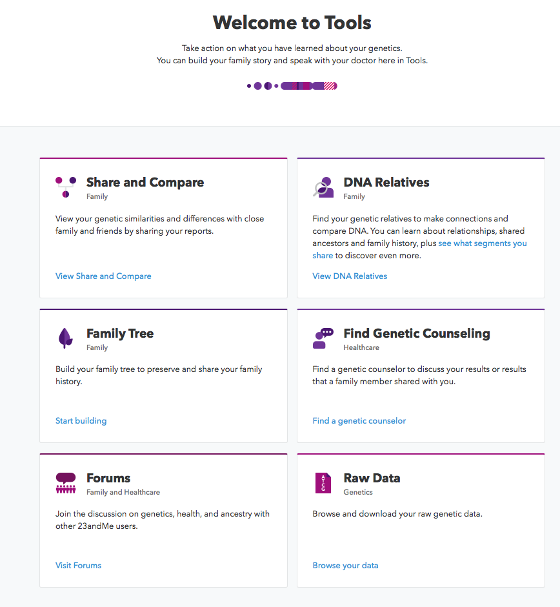
- On the, ‘Browse Your Raw Data’ web page select “Download Raw Data”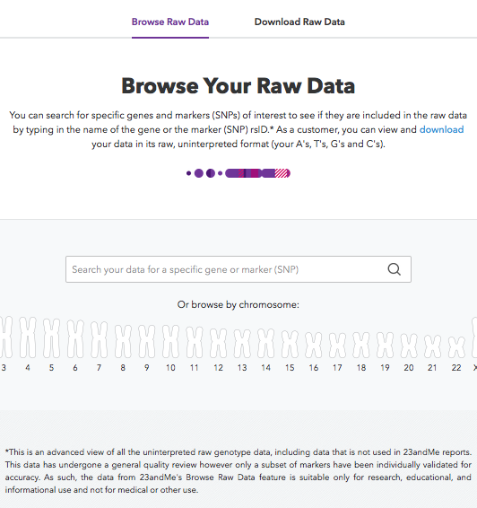
- On the web page titled, “Download Your Raw Data” scroll down until you find the section that asks what type of DNA data you want to download.
  - Select, ‘ALL DNA’ and enter your password.
  - Select the button “ Download Raw Data”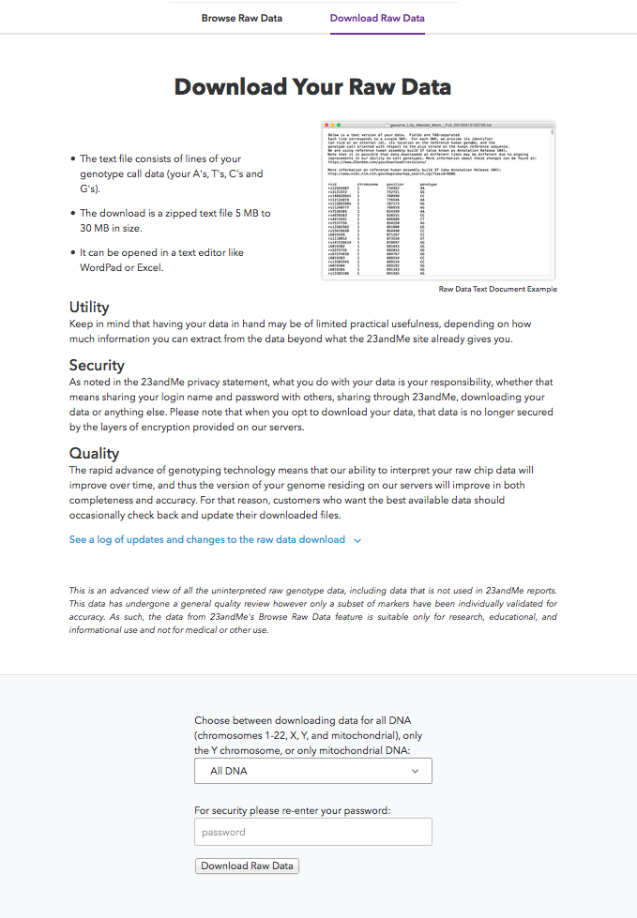
- A pop-up box should appear on your screen. Save the file.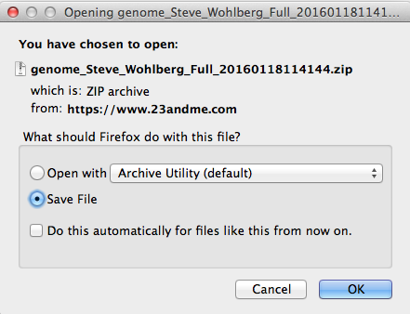

- Your file should be located on your ‘downloads’ folder.
- The file appears as a zip file.
- To open the file, click on the zip file. (You may need to click it 2 times or more)
- A new txt. File should appear on your downloads folder. Click it.
- When you open the txt File is should appear like this: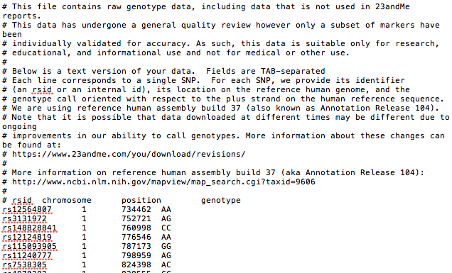
- Save the above file to an area that you can easily locate. You will need it to download your methylation and detox profiles .

Email your profiles to dryoungberginfo@gmail.com or fax them to (951) 271-4455

